1. Introduction

1.1 System outline
We media Program is platform that provides facility to read and publish news. In WMP, viewers have facility for reading, liking and sharing news. Content creator have facility for publish news and earn money. Ad creator have facility for create advertise by paying amount. Further ad creator and content creator shall manage their reports and profile.

1.2 Purpose
The purpose of We Media Program is to provide latest news and articles. The major objective is to publish and read the news and provides the facility to earn money by writing news.

1.3 Scope
Platform currently delivered content in English language and it is accessible only at the national level.

1.4 Technologies to be used
Front end | PHP 7.1
Back end | MySQL 4.9.1
Tools | Net beans IDE 8.2, VS Code 1.39.1
Operating system | Microsoft Windows 10

1.5 Functionalities

1.5.1 Expected functionalities.
- Registration
- Registration for Users and their authentication.
- Login
- Authorized user can log in.
- Manage news
- Content creator can manage the status of existing news as active/in-active.
- Feedback Management
- To manage the Feedback.
- FAQ Management
- To manage FAQ.
- Gallery Management
- Sub admin can manage Gallery as active/in-active and delete.
- Advertise Management
- Ad creator can manage the status of advertise of existing advertisements as active/in-active.

1.5.2 Exciting functionalities.
- Content recommendation engines.
- Wallet management.
- Content Ranking.

1.6 User Characteristics

1.6.1 Super Admin
- Manage operator account and permission (create, update, active/in-active).
- Review report of content creator.
- Review report of ad creator.
- Review report of platform revenue.
- Manage gallery (create, update, active/in-active).
- Manage slideshow (create, update, active/in-active).
- Manage news categories (create, update, active/in-active).
- Manage FAQ.

1.6.2 Operator
- Review content creators account approval request (Approve/Disapprove).
- Review ad creators account approval request (Approve/Disapprove).
- Review news, ads (Approve/Disapprove)
- Manage feedback.
- Review contact request.
- Help to content creator, ad creator & viewer.

1.6.3 Content Creator
- Write news
- Earn money based on estimated view on their news.
- View transaction history and report.
- Manage (Active/In-Active) their news.
- Send Feedback.
- View FAQ.
- Manage comments (approve/Disapprove/spam/delete).

1.6.4 Ad Creator
- Pay money and Create ads.
- Manage self-account and ad units.
- View transaction history and report.
- Send feedback.
- View FAQ.

1.6.5 Viewer
- Read news & stay up-to-date with much service.
- Like & dislike news.
- Follow content creator.
- Report inappropriate news.

1.7 Data Description

1.7.1 tbl_module_user

Sr.no | Name | Type | Constraint | Description
1. | module_user_id | int(5) | primary key | it set/get unique id of module user
2. | Image | varchar(50) | not null | it set/get image of module user
3. | user_name | varchar(30) | not null | it set/get username of module user
4. | first_name | varchar(30) | not null | it set/get first name of module user
5. | last_name | varchar(30) | not null | it set/get last name of module user
6. | Email | varchar(50) | Unique | it set/get email of module user
7. | Password | varchar(30) | not null | it set/get password of module user
8. | c_date | date | not null | it set/get creation date of module user
9. | u_date | timestamp | default(timestamp) | it set/get updation date of module user
10. | Ip | varchar(15) | not null | it set/get ip address of super admin device
11. | Status | tinyint(1) | default(0) | it set/get status of account
12. | Role | tinyint(1) | default(0) | it set/get role of module user
13. | Deletion | tinyint(1) | default(0) | it set/get account deleted or not

Description: It stores the details of sub-admin and operator. It is used for specific operator or sub-admin work.

1.7.2 tbl_slide_show

Sr.no | Name | Type | Constraint | Description
1. | slide_show_id | int(5) | primary key | it set/get the unique id of slideshow
2. | module_user _id | int(5) | foreign key (tbl_module_user) | it set/get the id of sub admin
3. | Image | varchar(100) | not null | it set/get image on slide
4. | Caption | varchar(100) | not null | it set/get caption on slide
5. | Orderby | int(5) | not null | it set/get order of image
6. | c_date | date | not null | it set/get creation date of slide
7. | u_date | Timestamp | default(timestamp) | it set/get updation date of slide
8. | Status | tinyint(1) | default(0) | it set/get active/inactive status
9. | Deletion | tinyint(1) | default(0) | it set/get slide is deleted or not

Description : It stores the details of slide. It is used for displaying slides on viewer side

1.7.3 tbl_qna

Sr.no | Name | Type | Constraint | Description
1. | qna_id | int(5) | primary key | it set/get the unique id of qna
2. | module_user_id | int(5) | foreign key (tbl_module_user) | it set/get the id of module user
3. | Question | varchar(200) | not null | it set/get the question
4. | Answer | varchar(200) | not null | it set/get the answer
5. | c_date | date | not null | it set/get the ip address of module user’s device
6. | u_date | timestamp | default(timestamp) | it set/get the status of module user (block/unblock)
7. | Status | tinyint(1) | default(0) | it set/get the qna creation date
8. | Deletion | tinyint(1) | default(0) | it set/get the question and answer is deleted or not

Description : It stores the details of question and answer. It is used for answering the specific question

1.7.4 tbl_category

Sr.no | Name | Type | Constraint | Description
1. | category_id | int(5) | primary key | it set/get the unique id of category
2. | module_user _id | int(5) | foreign key (tbl_module_user) | it set/get the id of module user
3. | Title | varchar(20) | not null | it set/get the title of category
4. | url | varchar(30) | not null | it set/get the url of category
5. | seo_title | varchar(20) | not null | it set/get the seo title for category
6. | seo_desc | varchar(255) | not null | it set/get the seo description for category
7. | c_date | Timestamp | Default  (timestamp) | it set/get the creation date of category
8. | Status | tinyint(1) | default (0) | it set/get the status of category
9. | Deletion | tinyint(1) | default (0) | it set/get the category is deleted or not

Description : It stores the details of news category. It is used for displaying the news category.

1.7.5 tbl_log

Sr.no | Name | Type | Constraint | Description
1. | log_id | int(5) | primary key | it set/get unique id of log
2. | Log | Text | not null | it set/get text written in log
3. | c_date | date | not null | it set/get creation date of log

Description : It stores the details of all users of platform. It is used for tracking the specific user.

1.7.6 tbl_viewer

Sr.no | Name | Type | Constraint | Description
1. | viewer_id | int(5) | primary key | it set/get the unique id of viewer
2. | Username | varchar(30) | not null | it set/get the username of viewer
3. | Email | svarchar(30) | Unique | it set/get the email of viewer
4. | Password | varchar(30) | not null | it set/get the password of viewer
5. | Ip | varchar(15) | not null | it set/get the ip address of viewer device
6. | Status | tinyint(1) | not null | it set/get the status of viewer (block/unblock)
7. | c_date | Date | not null | it set/get the account creation date
8. | u_date | timestamp | default(timestamp) | it set/get the account information update date

Description : It stores the details of viewer of the platform.

1.7.7 tbl_content_creator

Sr.no | Name | Type | Constraint | Description
1. | creator_id | int(5) | primary key | it set/get the unique id of category
2. | Username | varchar(20) | Unique | it set/get the username of content creator
3. | Email | varchar(20) | Unique | it set/get the email of content creator
4. | Mobile | int(10) | not null | it set/get the mobile number of content creator
5. | Password | varchar(30) | not null | it set/get the password of content creator
6. | channel_name | varchar(30) | Unique | it set/get the channel name of content creator
7. | channel_desc | varchar(255) | not null | it set/get the channel description of content creator
8. | Ip | varchar(15) | not null | it set/get the ip address of content creator
9. | account_  approval | tinyint(1) | not null | it set/get the account approved or not
10. | Status | tinyint(1) | not null | it set/get the status of content creator
11. | channel_logo | varchar(50) | not null | it set/get the channel logo of content creator
12. | u_date | timestamp | Default  (timestamp) | it set/get the updation date of content creator
13. | Deletion | tinyint(1) | default(0) | it set/get the content creator is deleted or not
14. | Monetization | tinyint(1) | default(0) | it set/get the monetization is on/off
15. | c_date | Date | not null | it set/get the creation date of content creator
16. | Privacy | tinyint(1) | default(0) | it set/get the account is public/private
17. | bank_name | varchar(30) | not null | it set/get the bank name of content creator
18. | account_  holdername | varchar(30) | not null | it set/get the account holder name
19. | ifsc_code | varchar(20) | not null | it set/get the ifsc code of bank
20. | Earning | decimal(12,2) | not null | it set/get the earning of content creator
21. | lifetime_withdraw_amount | decimal(12,2) | not null | it set/get the total amount withdraw by content creator till now

Description : It stores the details of content creator.

1.7.8 tbl_news

Sr.no | Name | Type | Constraint | Description
1. | news_id | int(5) | primary key | it set/get the unique id of news
2. | category_id | int(5) | foreign key (tbl_category) | it set/get the id of category
3. | creator_id | int(5) | forign key (tbl_content creator) | it set/get the id of creator
4. | Headline | varchar(100) | not null | it set/get the headline of news
5. | url | varchar(30) | not null | it set/get the url of news
6. | seo_title | varchar(20) | not null | it set/get the seo title for news
7. | seo_desc | varchar(255) | not null | it set/get the seo description for news
8. | file_attach | varchar(30) | not null | it set/get the image of news
9. | Summary | varchar(255) | not null | it set/get the summary of news
10. | details | varchar(255) | not null | it set/get the details of news
11. | views | int(10) | not null | it set/get the views of news
12. | c_date | timestamp | Default  (timestamp) | it set/get the creation date of news
13. | status | tinyint(1) | default(0) | it set/get the status of news
14. | approve | tinyint(1) | default(0) | it set/get the approval of news
15. | publish_date | Date | not null | it set/get the publish date of news
16. | rejection_msg | varchar(255) | not null | it set/get the reject message of news
17. | offline | tinyint(1) | default(0) | it set/get the news offline
18. | deletion | tinyint(1) | default(0) | it set/get the news is deleted or not
19. | rejected | tinyint(1) | default(0) | it set/get the news is rejected or not
20. | post_date | Date | not null | it set/get the post date of news

Description : It stores the details of news. It is used for publishing the news

1.7.9 tbl_feedback

Sr.no | Name | Type | Constraint | Description
1. | feed_id | int(5) | primary key | it set/get unique id of feedback
2. | user_id | int(5) | foreign key (tbl_viewer) | it set/get the id of user
3. | Subject | varchar(100) | not null | it set/get subject of feedback
4. | Description | varchar(255) | not null | it set/get description of feedback
5. | c_date | Date | not null | it set/get creation date of feedback
6. | u_date | timestamp | default(timestamp) | it set/get updation date of feedback
7. | Ip | varchar(15) | not null | it set/get ip address of user’s device
8. | Role | int(1) | not null | it get/set the role of user(viewer/sd_creator/content_creator)
9. | module_  user_id | int(5) | foreign key (tbl_module_user) | it get/set the id of module_user
10. | Image | varchar(20) | not null | it get/set the image for feedback
11. | Status | tinyint(1) | default(0) | it set/get status of feedback
12. | Deletion | tinyint(1) | default(0) | it set/get feedback is deleted or not

Description : It stores the details of all users feedback. It is used for identifying the user problem

1.7.10 tbl_action

Sr.no | Name | Type | Constraint | Description
1. | action_id | int(5) | primary key | it set/get unique id of rating
2. | viewer_id | int(5) | foreign key (tbl_viewer) | it set/get the id of user
3. | news_id | int(10) | foreign key (tbl_news) | it set/get the news id
4. | Rating | tinyint(1) | default(0) | it set/get the action of rating
5. | c_date | Date | not null | it set/get creation date rating
6. | u_date | timestamp | default(timestamp) | it set/get updation date of rating
7. | Ip | varchar(15) | not null | it set/get ip address of user’s device
8. | Status | tinyint(1) | default(0) | it set/get status of feedback
9. | Deletion | tinyint(1) | default(0) | it set/get rating is deleted or not

Description : It stores the details of rating. It is used for ranking the popular news as per likes.

1.7.11 tbl_comment

Sr.no | Name | Type | Constraint | Description
1. | comment_id | int(5) | primary key | it set/get unique id of report
2. | news_id | int(5) | foreign key (tbl_news) | it set/get the id of news
3. | user_name | varchar(20) | Foreign key(tbl_viewer) | it set/get username
4. | Comment | varchar(30) | not null | it set/get comment
5. | c_date | date | not null | it set/get post date
6. | Status | int(2) | not null | it set/get the status
7. | Deletion | tinyint(4) | not null | it set/get comment is deleted or not

Description : It stores the details of comment on news .

1.7.12 tbl_follower

Sr.no | Name | Type | Constraint | Description
1. | follower_id | int(5) | primary key | it set/get unique id of report
2. | content_creator_id | int(5) | foreign key (tbl_content_creator) | it set/get the id of content creator
3. | viewer_id | int(5) | foreign key (tbl_viewer) | it set/get the id of viewer
4. | Date | Date | not null | it set/get date of following the content creator

Description : It stores the details of follower. It is used for identifying the popular content creator.

1.7.13 tbl_ad_creator

Sr.no | Name | Type | Constraint | Description
1. | ad_creator_id | int(5) | primary key | it set/get unique id of ad creator
2. | profile_image | varchar(30) | not null | it set/get profile image of ad creator
3. | Username | varchar(30) | Unique | it set/get username of ad creator
4. | company_name | varchar(30) | not null | it set/get company name of ad creator
5. | About | varchar(255) | not null | it set/get about ad creator
6. | Phone | int(10) | not null | it set/get phone number of ad creator
7. | email | varchar(30) | Unique | it set/get email address of ad creator
8. | Password | varchar(30) | not null | it set/get password of ad creator
9. | c_date | Date | not null | it set/get creation date of ad creator
10. | u_date | timestamp | default(timestamp) | it set/get updation date of ad creator
11. | Ip | varchar(15) | not null | it set/get ip address of ad creator
12. | Status | tinyint(1) | default(0) | it set/get active/inactive status
13. | cvv_number | int(3) | not null | it set/get cvv number of card of ad creator
14. | card_number | int(19) | Unique | it set/get card number of ad creator
15. | Wallet | decimal(12,2) | not null | it set/get balance of ad creator
16. | ad_unit_amount | decimal(12,2) | not null | it set/get deposit for ad units
17. | lifetime_amount | decimal(12,2) | not null | it set/get lifetime deposit of ad creator
18. | spend_amount | decimal(12,2) | not null | it set/get spend amount on ad by ad creator

Description : It stores the details of ad creator.

1.7.14 tbl_adunit

Sr.no | Name | Type | Constraint | Description
1. | ad_id | int(5) | primary key | it set/get unique id of ads
2. | category_id | int(5) | foreign key (tbl_category) | it set/get the id of category
3. | ad_creator_id | int(5) | foreign key (tbl_ad_creator) | it set/get the id of ad creator
4. | url | varchar(30) | not null | it set/get the url of ads
5. | seo_title | varchar(100) | not null | it set/get the seo title for ads
6. | seo_desc | varchar(255) | not null | it set/get the seo description for ads
7. | file_attach | varchar(50) | not null | it set/get images of ads
8. | summary | Text | not null | it set/get summary of ads unit
9. | details | Text | not null | it set/get details of ads unit
10. | views | int(10) | not null | it set/get views of ads
11. | u_date | timestamp | default(timestamp) | it set/get modify date of ads
12. | status | tinyint(1) | default(0) | it set/get status of ads
13. | approve | tinyint(1) | default(0) | it set/get approval of ads
14. | publish_date | Date | not null | it set/get publish date of ads
15. | rejection_msg | varchar(255) | not null | it set/get reject message of ads
16. | offline | tinyint(1) | default(0) | it set/get ads offline (if invalid)
17. | deletion | tinyint(1) | default(0) | it set/get ads is deleted or not
18. | rejected | tinyint(1) | default(0) | it set/get rejected ads
19. | post_date | Date | not null | it set/get post date of ads
20. | cpc | decimal(3,2) | not null | it set/get the amount of cost per click

Description : It stores the details of ads. It is used for displaying ads in platform.

1.7.15 tbl_content_creator_earning

Sr.no | Name | Type | Constraint | Description
1. | transaction_id | int(5) | primary key | it set/get unique id of report
2. | content_creator_id | int(5) | foreign key (tbl_content_creator) | it set/get id of content creator
3. | Earning | decimal(12,2) | not null | it set/get total earning of content creator
4. | withdrawal_amount | decimal(12,2) | not null | it set/get withdraw amount by content creator
5. | total_amount | decimal(12,2) | not null | it set/get total earned amount of content creator
6. | c_date | Date | not null | it set/get creation date of earning account
7. | u_date | Timestamp | default(timestamp) | it set/get updation date of transaction(withdrawal)
8. | Ip | varchar(15) | not null | it set/get ip address of content creator’s device
9. | Status | tinyint(1) | default(0) | it set/get status

Description : It stores the details of content creator earnings.

1.7.16 tbl_ad_report

Sr.no | Name | Type | Constraint | Description
1. | report_id | int(5) | primary key | it set/get unique id of report
2. | ad_id | int(5) | foreign key (tbl_adunit) | it set/get the id of ad
3. | news_id | int(5) | foreign key (tbl_news) | it set/get the news id
4. | Cpc | decimal(3,2) | not null | it set/get the cpc of ad
5. | company_earning | decimal(12,2) | not null | it set/get earning of company
6. | creator _earning | decimal(12,2) | not null | it set/get the creator earning
7. | monetizer_balance | decimal(12,2) | not null | it set/get ad creator balance
8. | c_date | date | not null | it set/get the date

Description : It stores the details of company earning, creator earning.

1.7.17 tbl_gallery

Sr.no | Name | Type | Constraint | Description
1. | gallery_id | int(5) | primary key | it set/get unique id of gallery
2. | module_user_id | int(5) | foreign key (tbl_module_user) | it set/get the id of module_user
3. | title | varchar(20) | not null | it set/get the title of gallery
4. | url | decimal(3,2) | not null | it set/get the url of gallery
5. | seo_title | decimal(12,2) | not null | it set/get the seo title of gallery
6. | seo_desc | decimal(12,2) | not null | it set/get the seo description of gallery
7. | location | decimal(12,2) | not null | it set/get the location of gallery
8. | c_date | date | not null | it set/get the creation date of gallery
9. | u_date | varchar(15) | not null | it set/get the modify date of gallery
10. | status | tinyint(1) | default(0) | it set/get the status of gallery
11. | deletion | tinyint(1) | default(0) | it set/get gallery is deleted or not

Description : It stores the details of gallery.

1.7.18 tbl_picture

Sr.no | Name | Type | Constraint | Description
1. | picture_id | int(5) | primary key | it set/get unique id of gallery
2. | module_user_id | int(5) | foreign key (tbl_module_user) | it set/get the id of module_user
3. | gallery_id | int(5) | foreign key (tbl_gallery) | it set/get the id of gallery
4. | caption | varchar(100) | not null | it set/get the caption of picture
5. | image | varchar(20) | not null | it set/get the image of picture
6. | c_date | date | not null | it set/get the creation date of picture
7. | u_date | timestamp | default(timestamp) | it set/get the modify date of gallery
8. | status | tinyint(1) | default(0) | it set/get the status of gallery
9. | deletion | tinyint(1) | default(0) | it set/get gallery is deleted or not

Description : It stores the details of picture. It used to display the picture on viewer side.

1.8 Summary
Expected Functionalities | Exciting Functionalities
Registration | Content Recommendation Engine
Login | Wallet Management
Manage News | Content Ranking
Feedback Management
Gallery Management
Advertise Management
Count - 6 | Count - 3
Total Functionalities – 9
Total Relations - 18

2. System Design

2.1 GUI Design

2.1.1 Admin

2.1.2 Operator

2.1.3 Content Creator

2.1.4 Ad Creator

2.1.5 Viewer

2. System Analysis

2.1 Identification of Need
We Media Program is a platform that provides facility to read and publish news. In We Media Program, viewers have facility for reading, liking and sharing news. Content creator has facility for publish news and earn money. Ad creator have facility for create advertise by paying amount. Further ad creator and content creator shall manage their reports and profile.

2.4 Software development process

2.4.1 Prototype Model

Prototype is model when the requirement of system is change. In this we media program as per viewer requirements there are changes in platform must be made.

The main objective of these we media program is to provide user friendly and quality service for publish news and ads as well as earn money.

The requirement for we media program could be complex, so that viewers feedback are highly valuable and increase the accuracy to match viewer requirements for next development design.

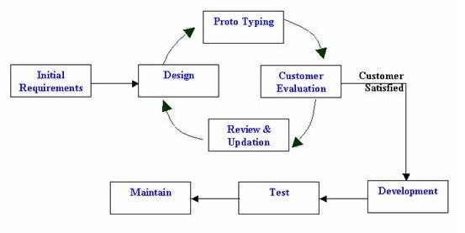

[2.4.1 figure prototype ]

2.4.1.1 Initial Requirements
This step involves understanding the very basics requirements in terms of user interface, language understanding for news and security of Viewer/Ads creator/Content creator account. The more intricate details of the internal design and external aspects like performance and security can be ignored at this stage.

2.4.1.2 Design
System design helps in specifying hardware and system requirements and also helps in defining overall platform architecture and user interface.

2.4.1.3 Prototyping
The initial Prototype is developed in this stage, where the very basic requirements of WMP are showcased and user interfaces are provided. These features may not exactly work in the same manner internally in the actual platform developed. While, the workarounds are used to give the same look and feel to the user in the prototype developed for WMP.

2.4.1.4 Customer Evaluation
The prototype developed is then presented to the user and the other important Admin in the platform. The feedback is collected from the viewer/Ads creator/Content creator in an organized manner and used for further enhancements in the platform under development.

2.4.1.5 Review and Updation
The feedback and the review comments are discussed during this stage and some negotiations happen with the viewer/ads creator/content creator based on factors like – time and understanding constraints and technical feasibility of the actual implementation. The changes accepted are again incorporated in the new Prototype developed and the cycle repeats until the viewer/ads creator/content creator expectations are met.

2.4.1.6 Development
With inputs from review and updation phase, the system in first developed in small programs called units, which are integrated.

2.4.1.7 Test
Each unit is developed and tested for its functionality which is referred to as Test in all the units developed in the implementation phase are integrated into a system after testing of each unit. Post integration the entire platform is tested for any faults and failures.

2.4.1.8 Maintain
The requirement for we media program could be complex, so that viewers feedback are highly valuable and increase the accuracy to match viewer requirements for next development design.

3. Conceptual diagram

3.1. Use case diagram

3.1.1 Super Admin use case diagram

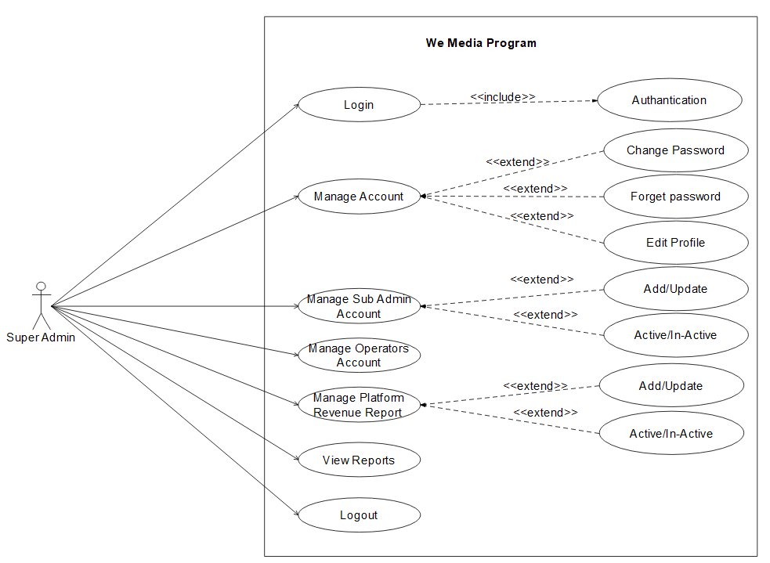

3.1.2 Sub Admin use case diagram

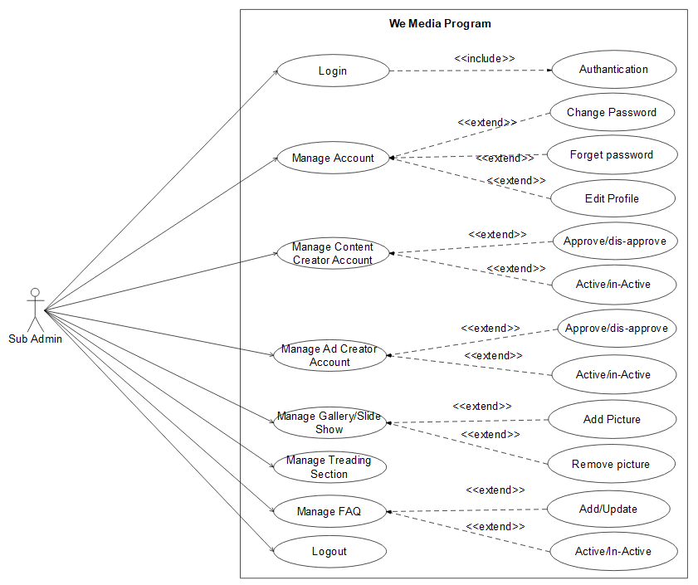

3.1.3 Operator use case diagram

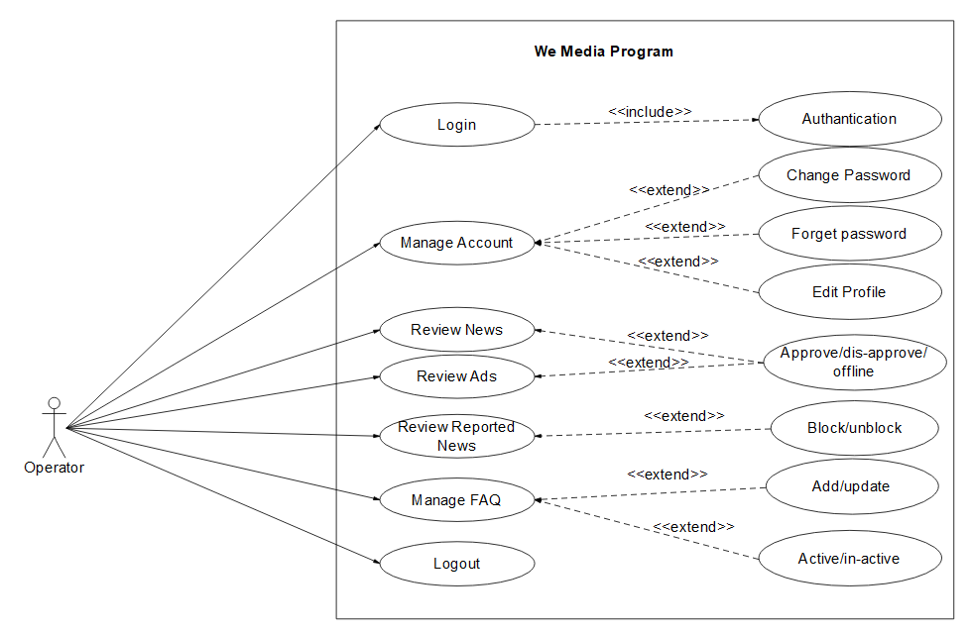

3.1.4 Content creator use case diagram

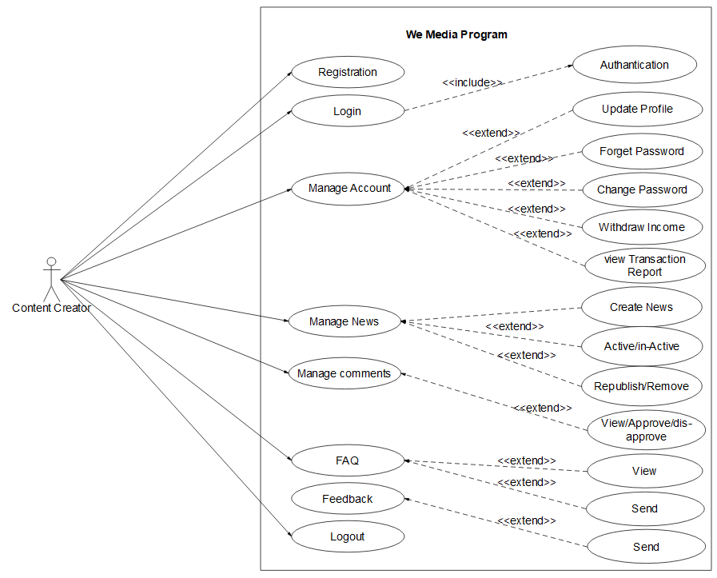

3.1.5 Ad creator use case diagram

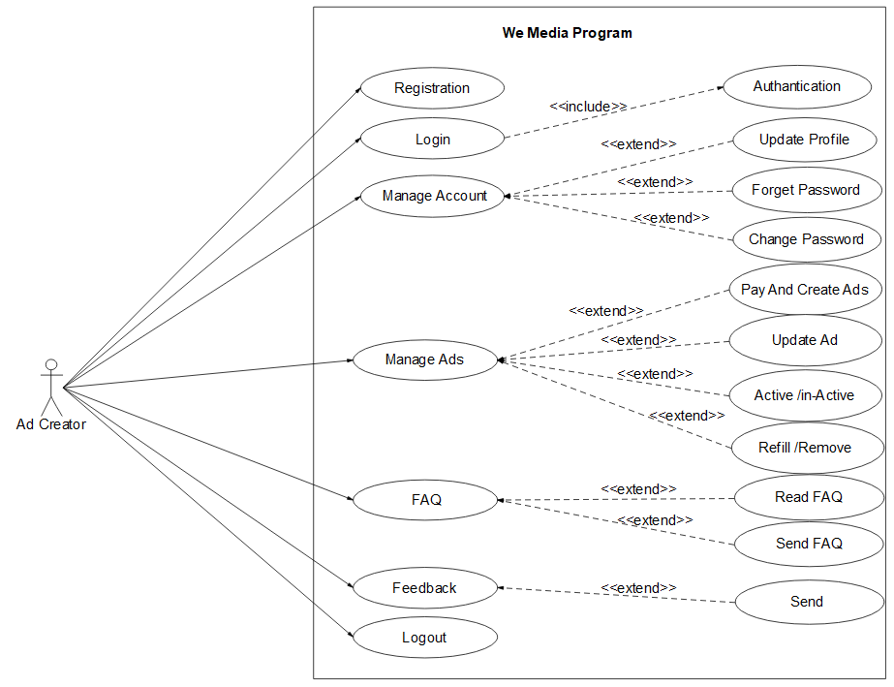

3.1.6 Viewer use case diagram

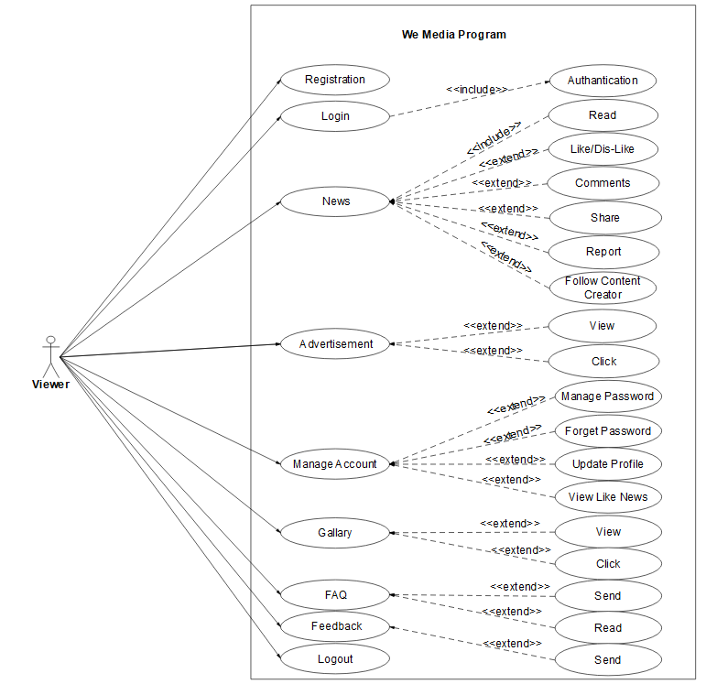

3.2. Activity diagram

3.2.1 Registration activiy diagram

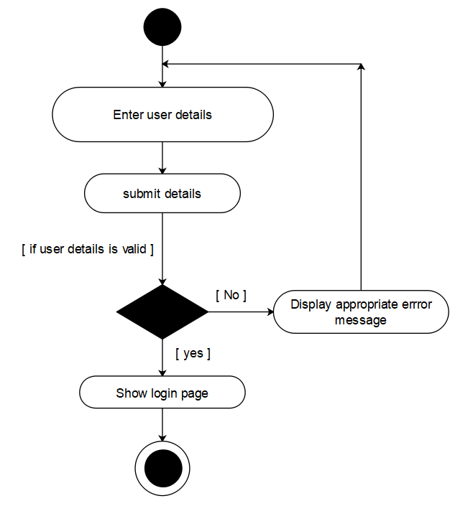

3.2.2 Login activiy diagram

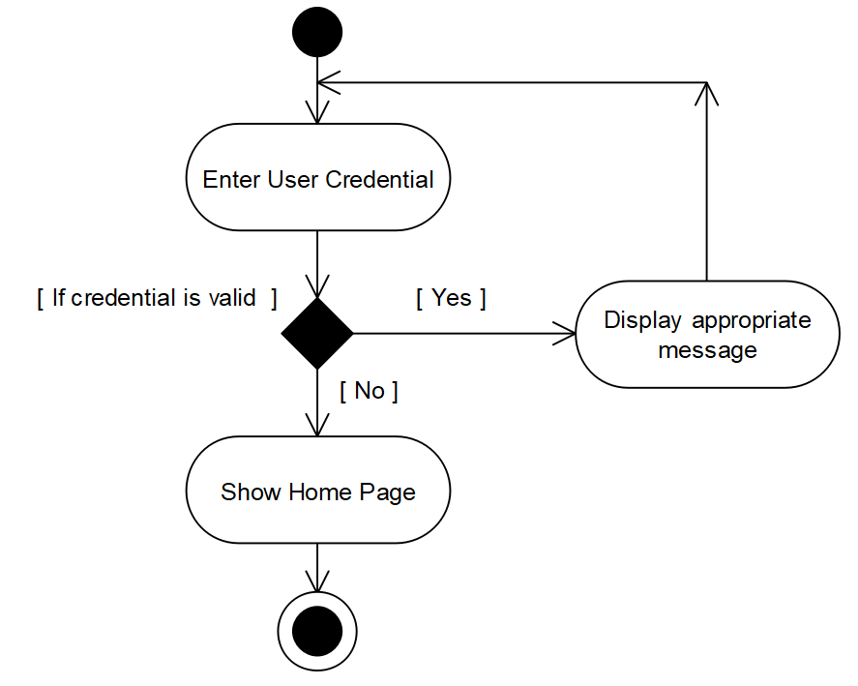

3.2.3 Sub-admin activiy diagram

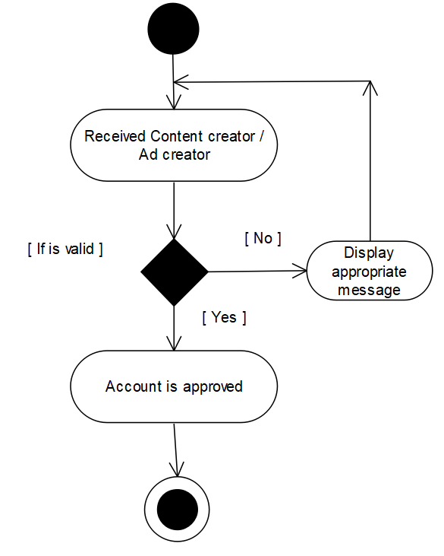

3.2.4 Operator activiy diagram

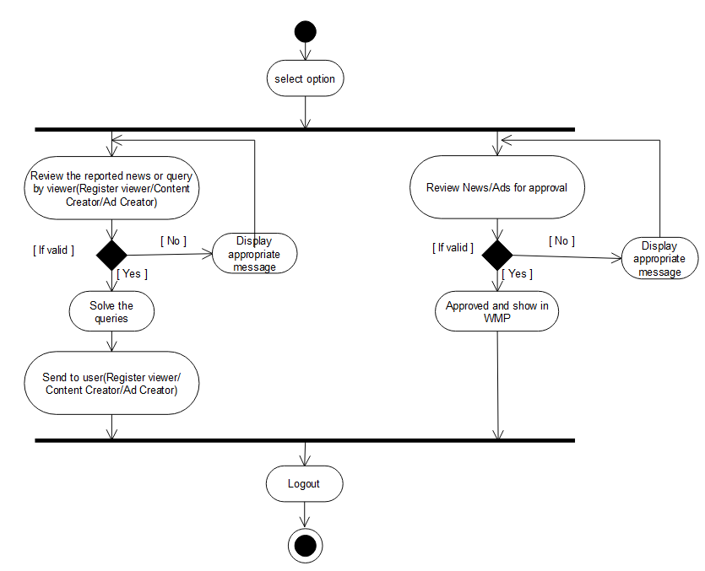

3.2.5 Ad creator activiy diagram

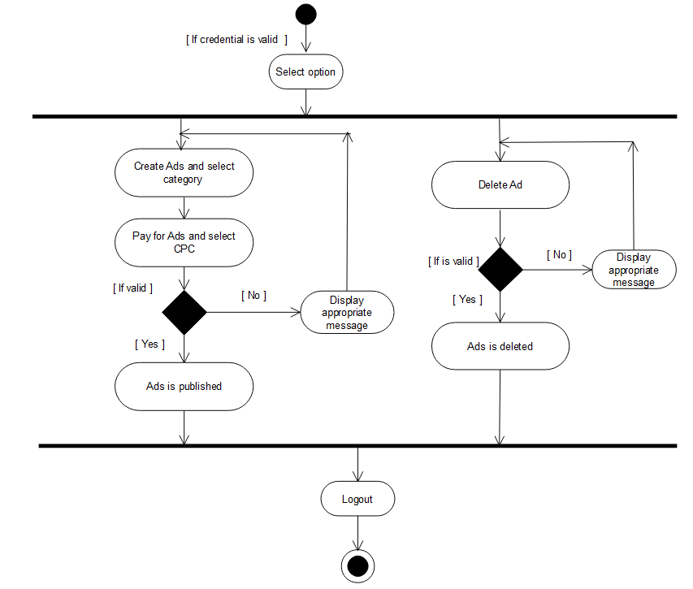

3.2.6 Content creator activiy diagram

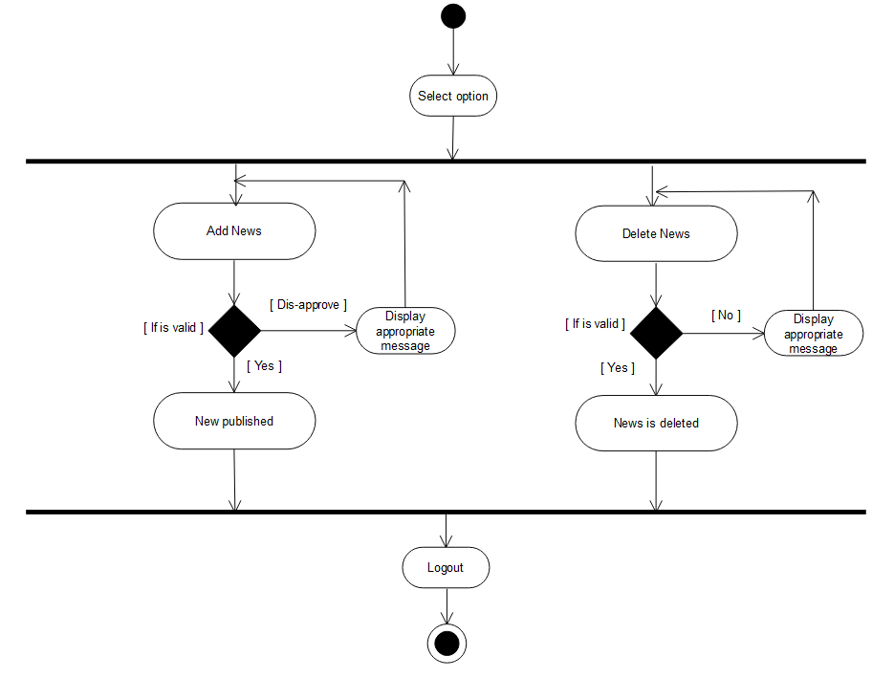

4. System Design

4.2 User Interface Design

4.2.1 Viewer sign up
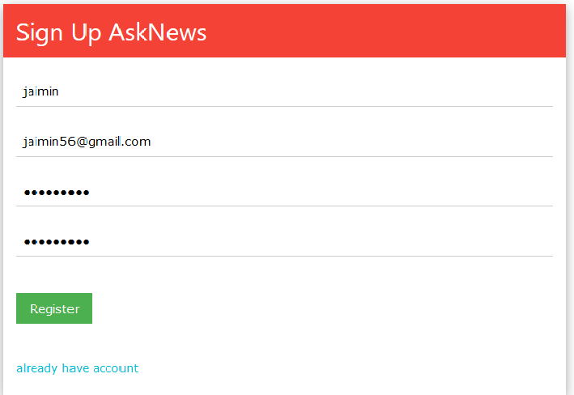
[4.2.1 Interface of viewer sign up]
Description: This is a sign up page for viewer. Enter username, email id and password and click on sign up button to redirect to login page.

4.2.2 Viewer login
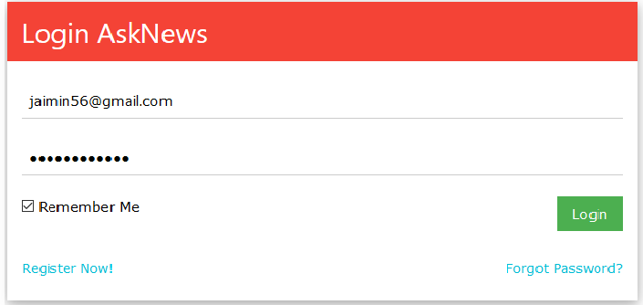
[4.2.2 Interface of viewer login]
Description: This is a login page of viewer. Enter email id and password and click on login button to login into home page of site.

4.2.3 Viewer category
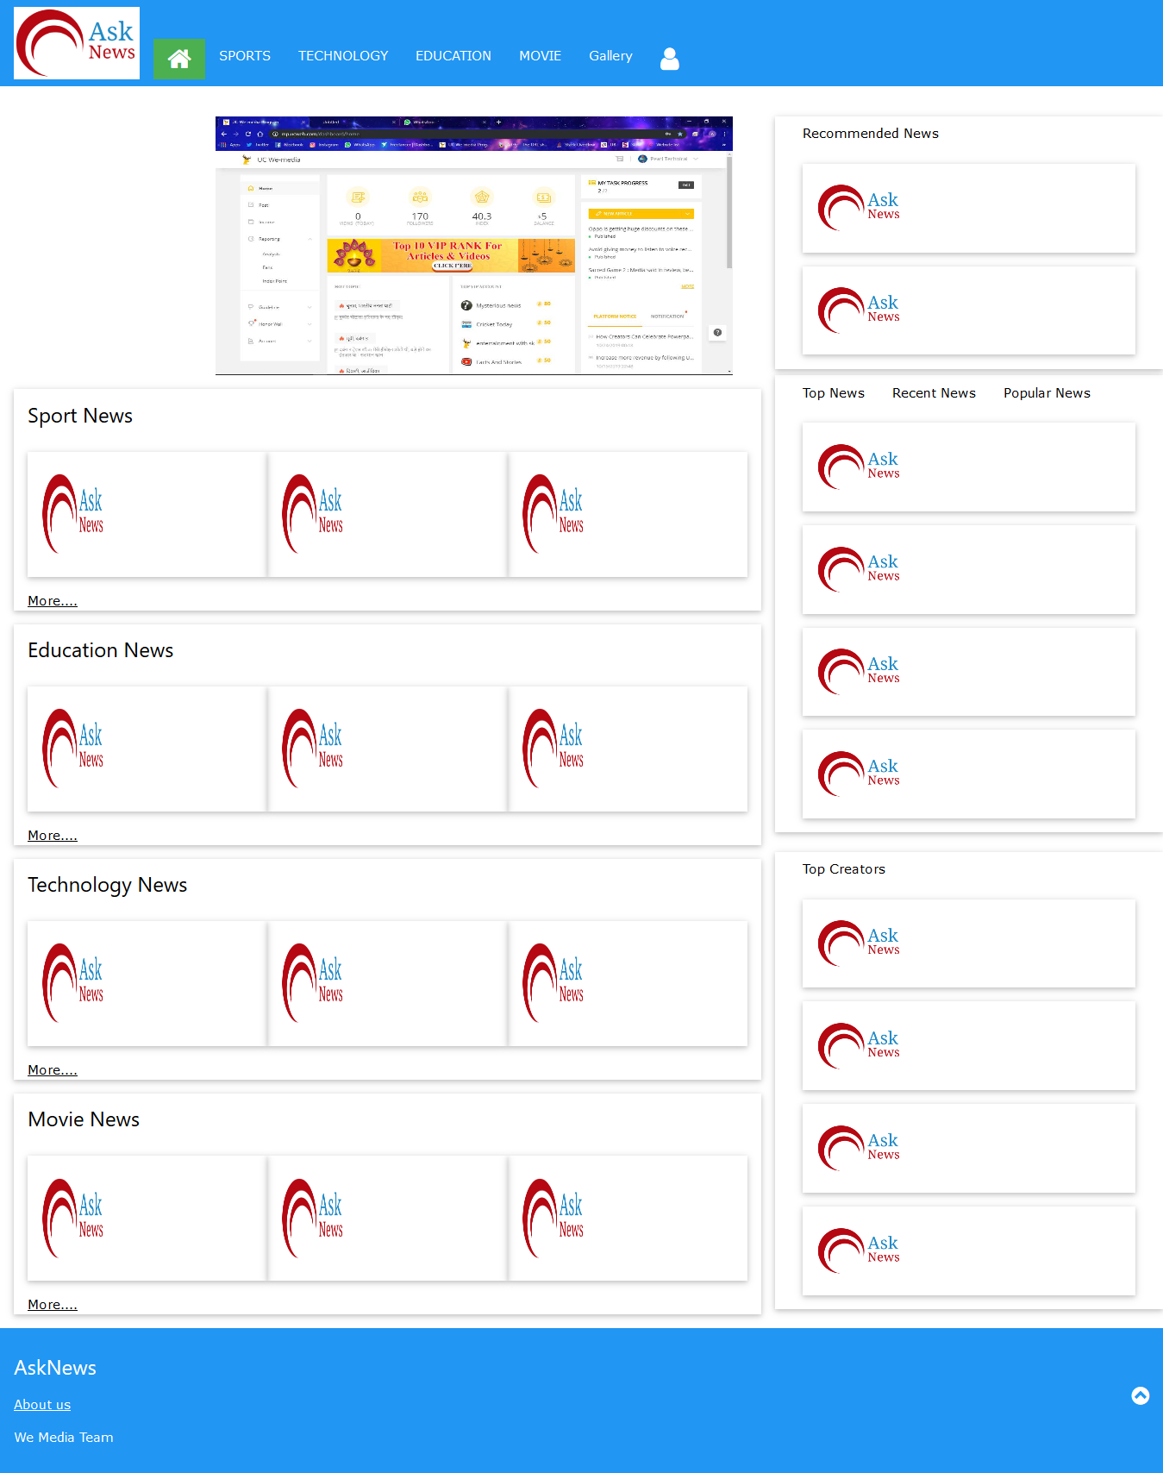
[4.2.3 Interface of viewer category]
Description: This is a home page for viewer where viewer read the news category wise.

4.2.4 Ad creator sign up
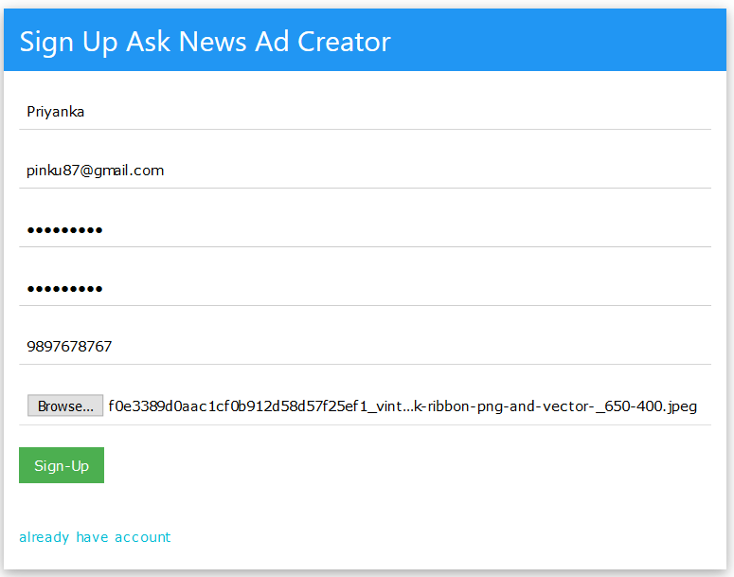
[4.2.4 Interface of ad creator sign up]
Description: This is a sign up page for ad creator. Enter username, email id, password, mobile number and profile picture and click on sign up button to redirect to login page.

4.2.5 Ad creator login
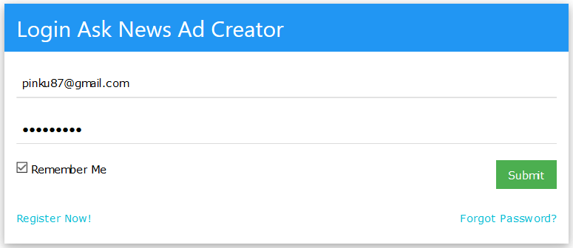
[4.2.5 Interface of ad creator login]
Description: This is a login page of ad creator. Enter email id and password and click on login button to login into dashboard page.

4.2.6 Ad creator’s dashboard
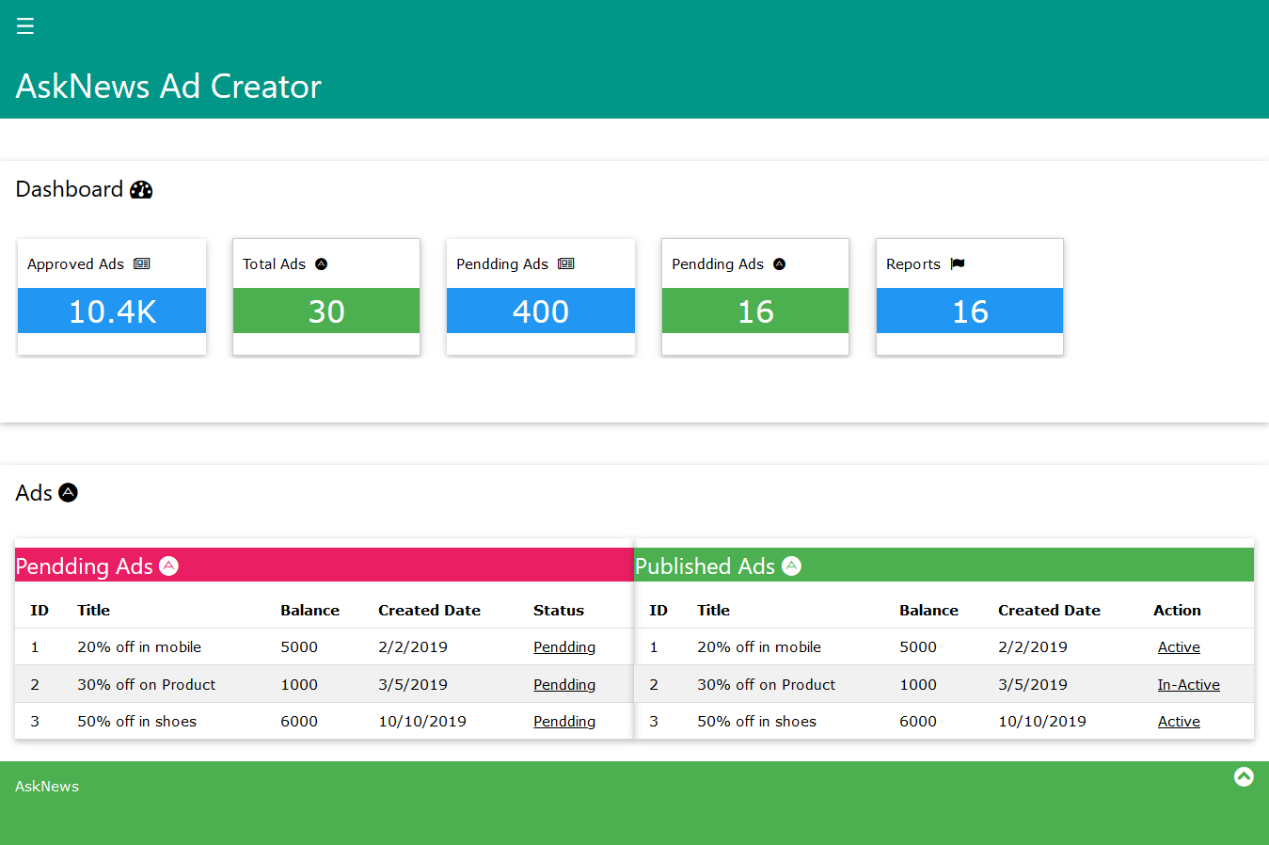
[4.2.6 Interface of super ad creator’s dashboard]
Description: This is use to display all details of ads.

4.2.7 Ad creator creates ads
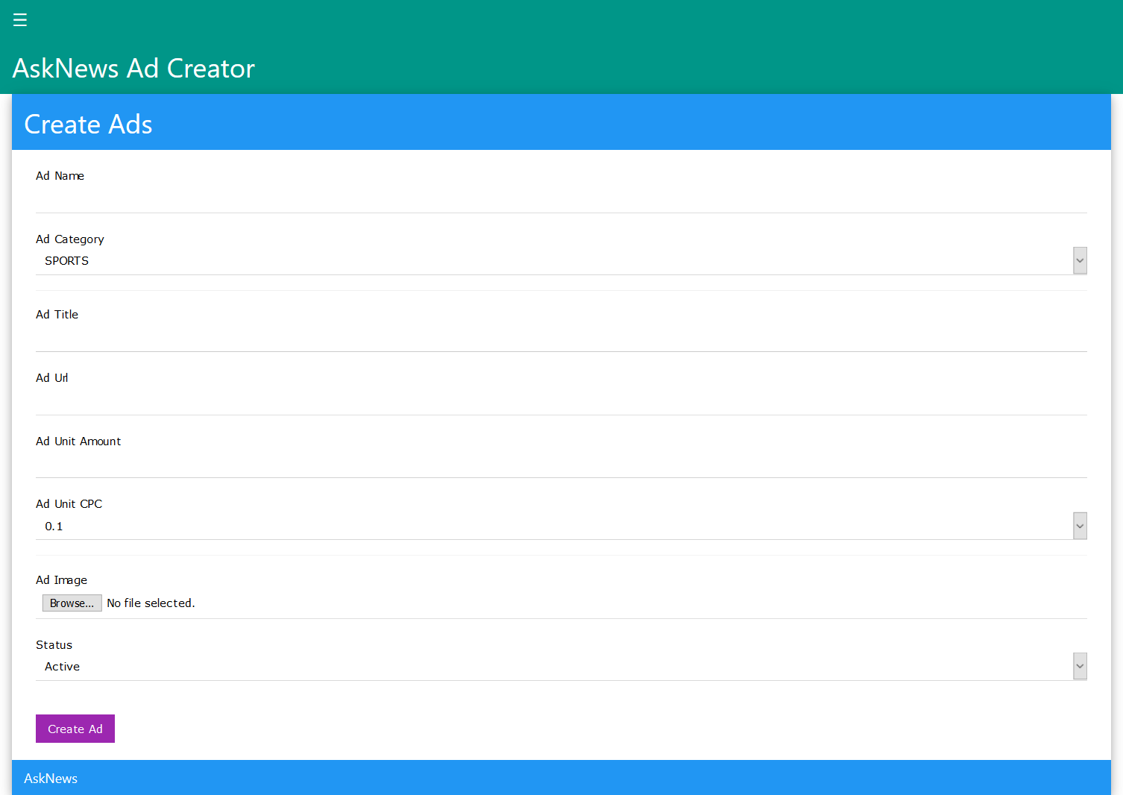
[4.2.7 Interface of ad creator login]
Description: This is a page for creating new ads. Enter advertisement details and click on create ads button.

4.2.8 Ad creator feedback form

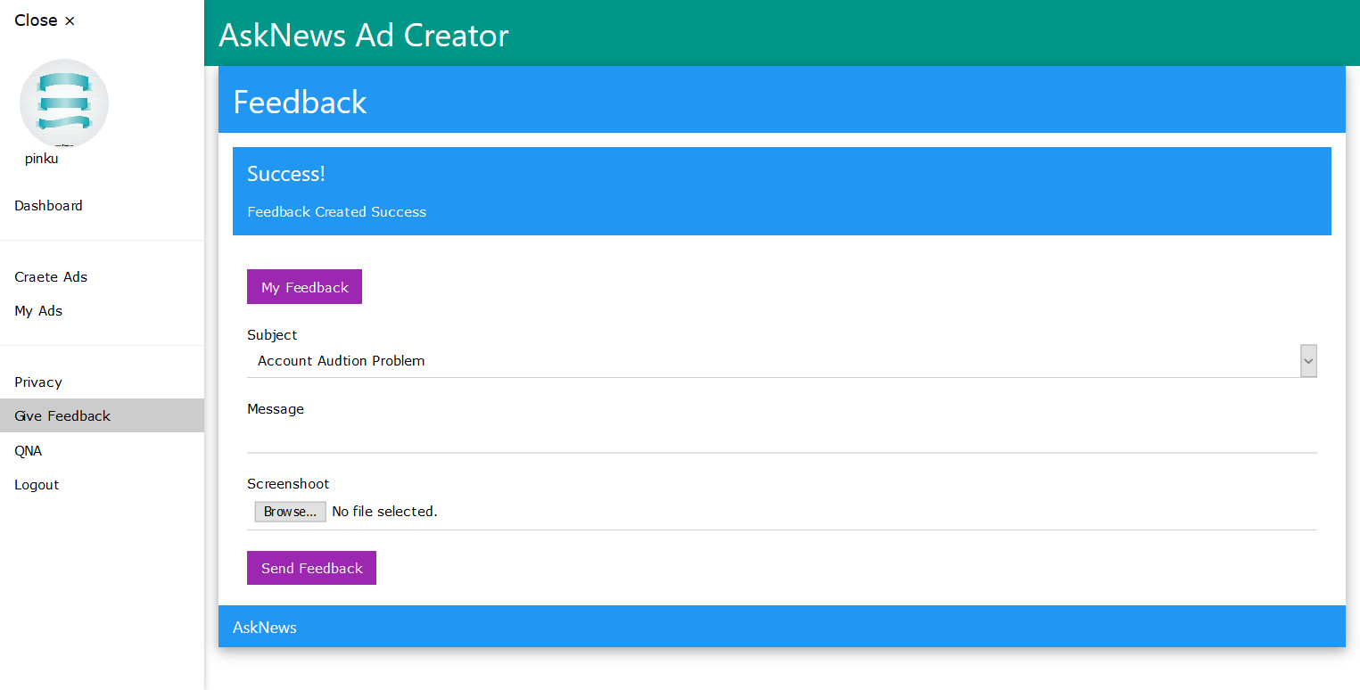
[4.2.8 Interface of ad creator feedback form]
Description: This is a page of feedback for ad creator. Enter details of feedback.

4.2.9 Content Creator login
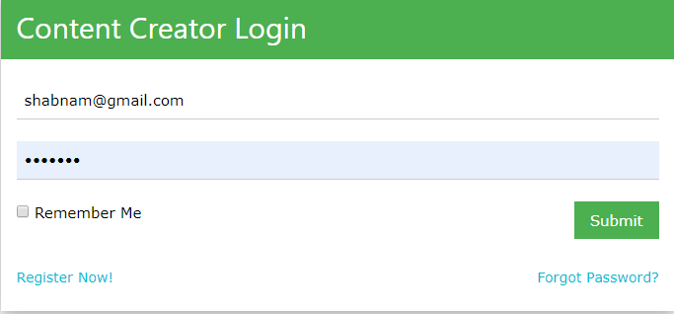
[ 4.2.9 Interface of content creator login]
Description: This is a login page of content creator. Enter email id and password and click on login button to login into home page.

4.2.10 Content creator’s dashboard
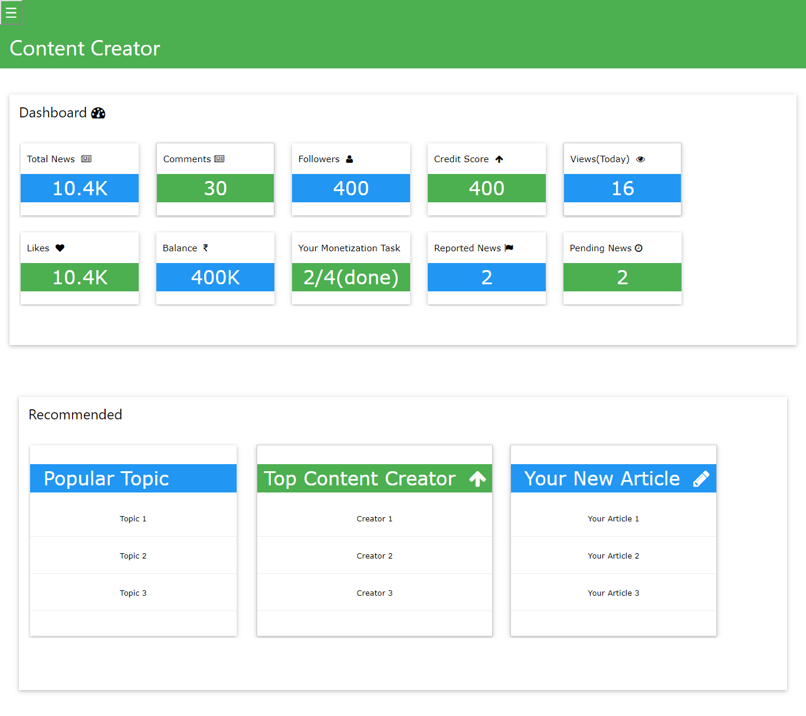
[4.2.10 Interface of content creator’s dashboard]
Description: This is use to display all details of news.

4.2.11 Content Creator Add News form
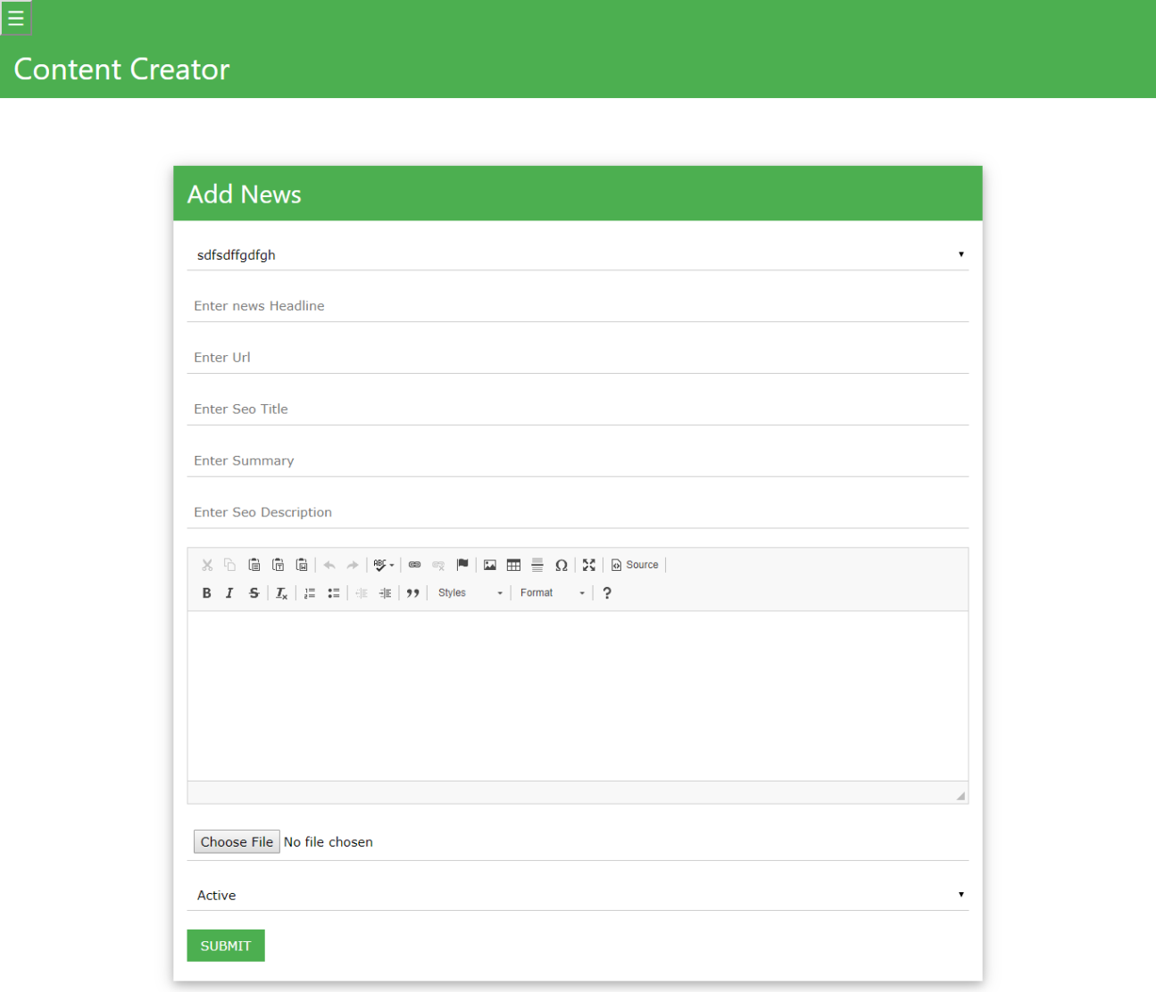
[ 4.2.11 Interface of content creator Add News form]
Description: This is a page for creating new news by content creator. Enter all the details of news and click on submit.

4.2.12 Super admin login
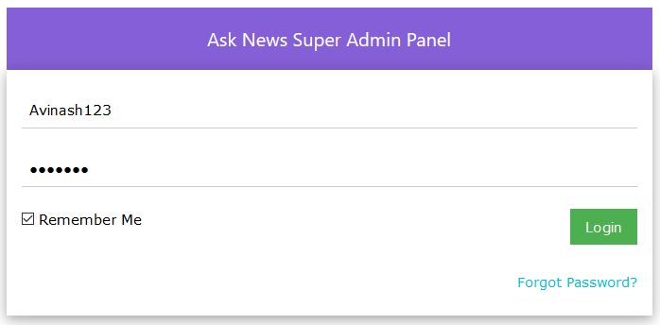
[4.2.12 Interface of super admin login]
Description: This is a login page for super admin. Enter username, email id and password and click on login button to redirect to dashboard.

4.2.13 Super admin’s dashboard
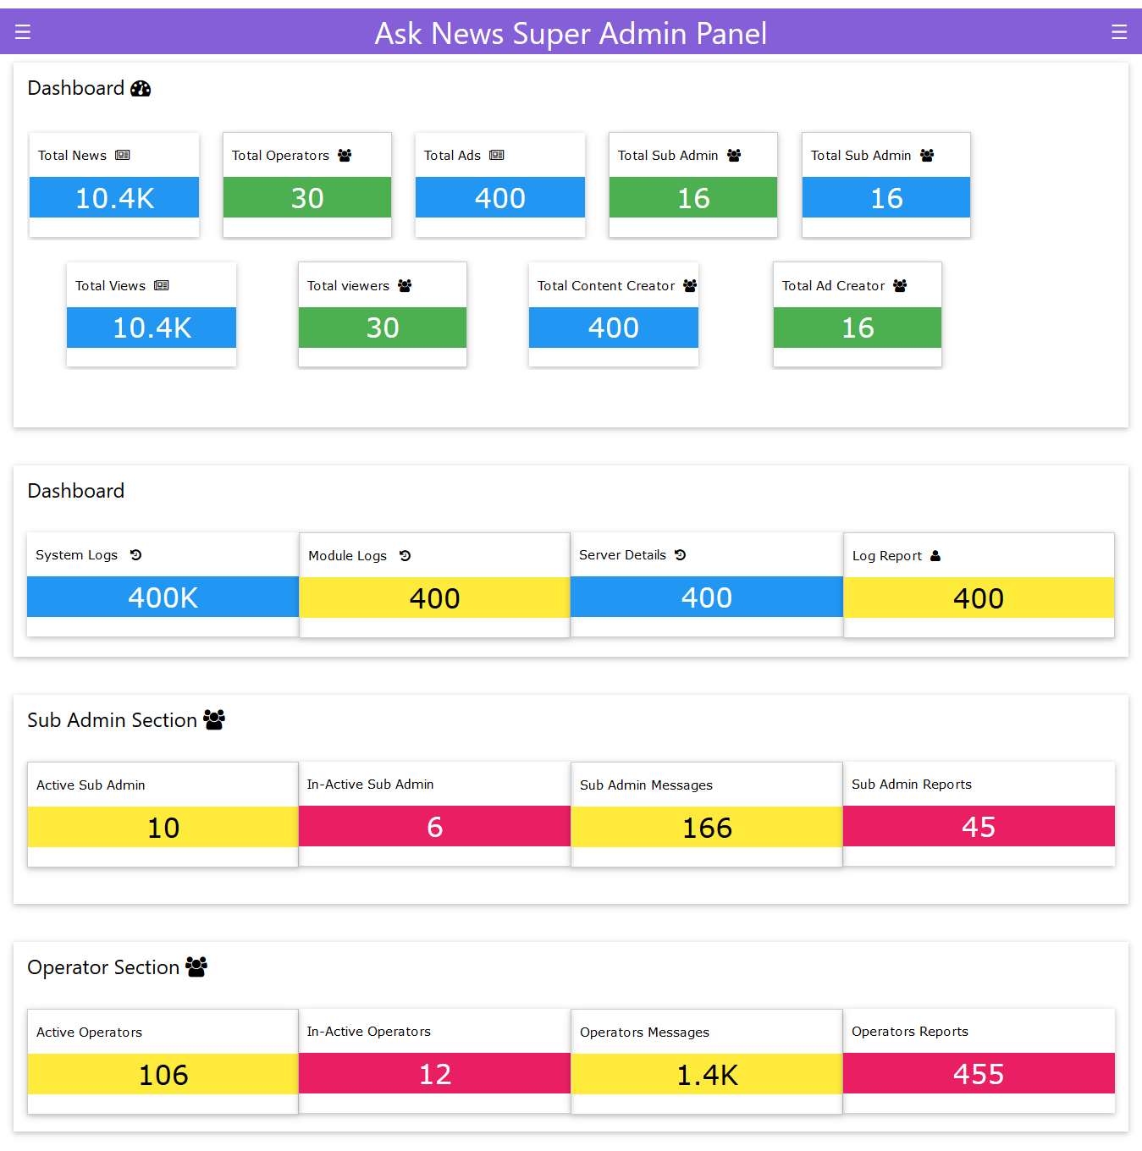
[4.2.13 Interface of super admin’s dashboard]
Description: This is use to display all details.

4.2.14 Super admin create new user
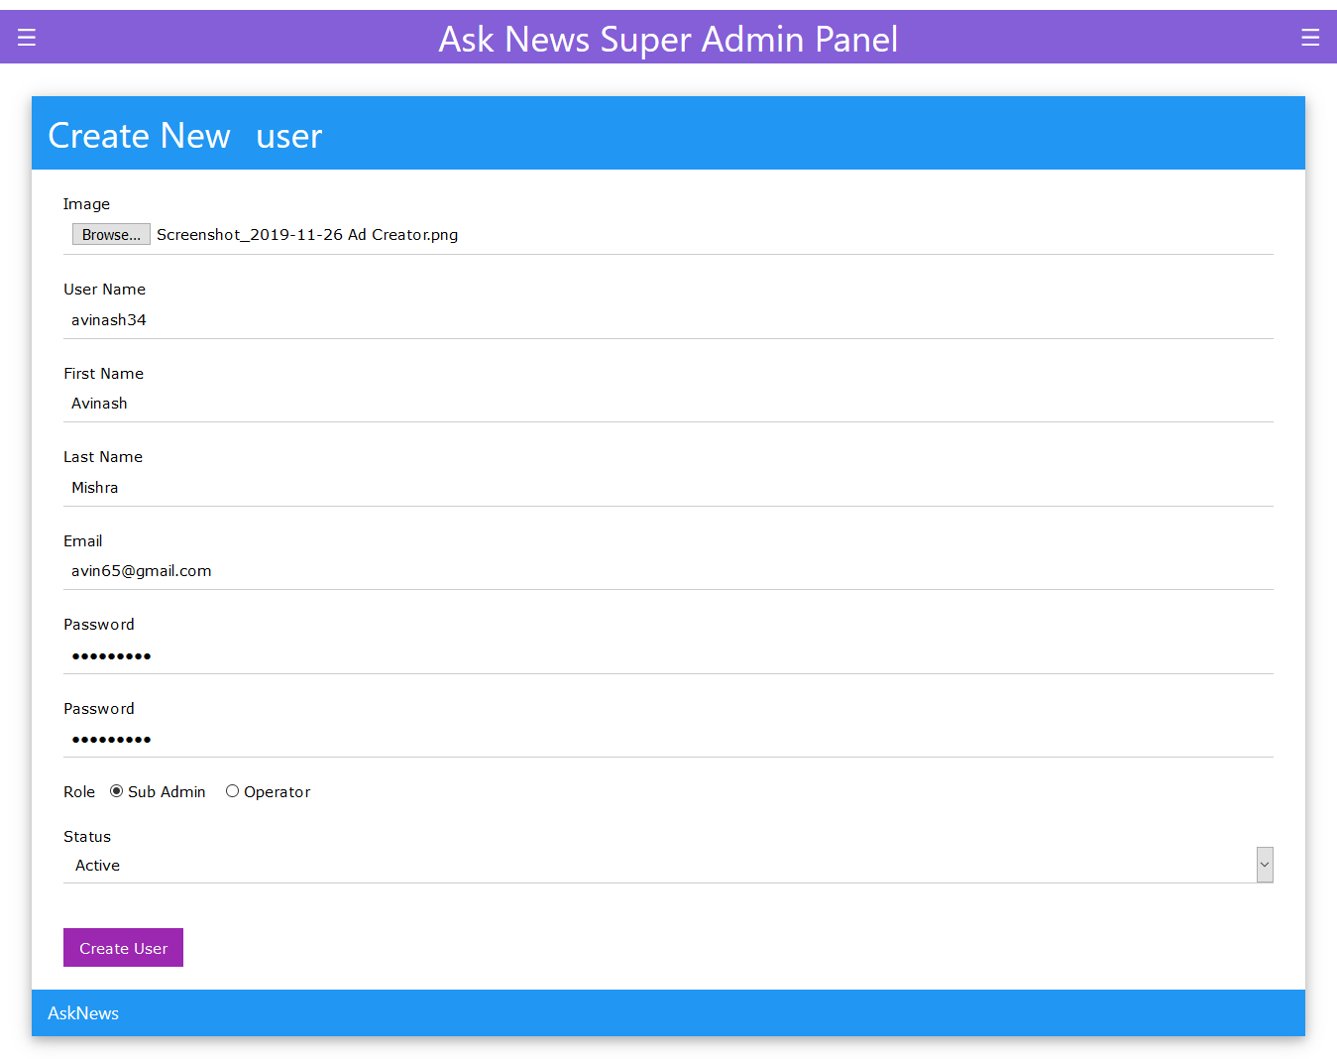
[4.2.14 Interface of super admin create new user]
Description: This is a creating new user page of super admin. Enter user details and click on create user button.

4.2.15 Super admin manage user
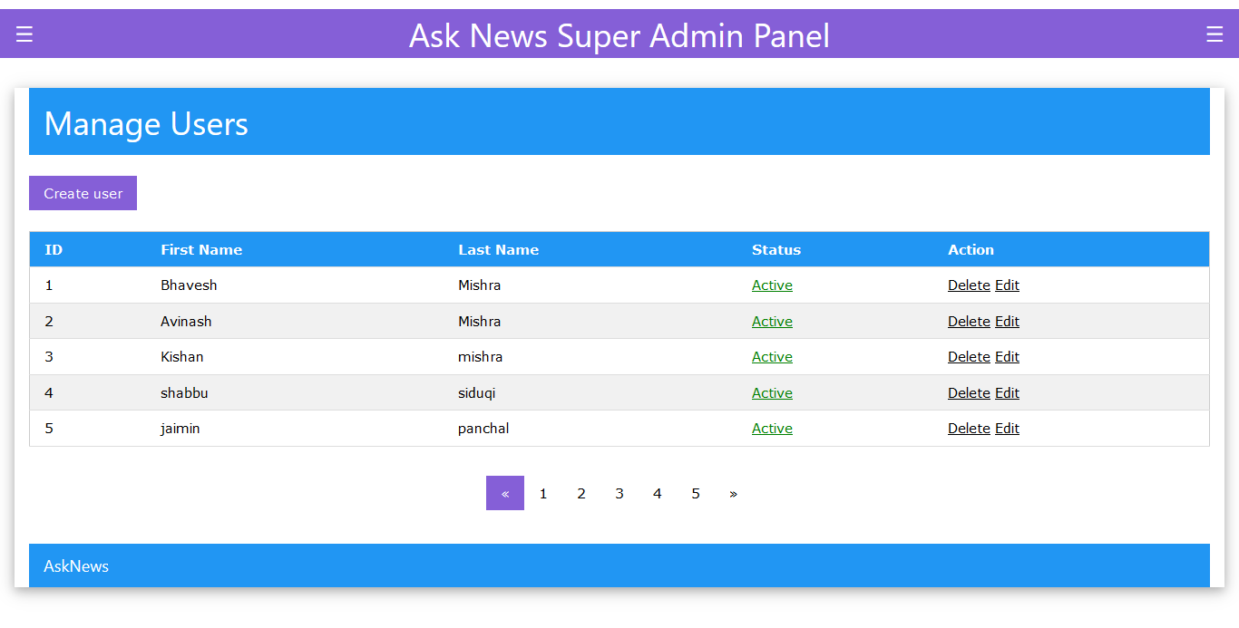
[4.2.15 Interface of super admin manage user]
Description: This is a page for manage user by super admin.

4.2.16 Super admin manage content creator
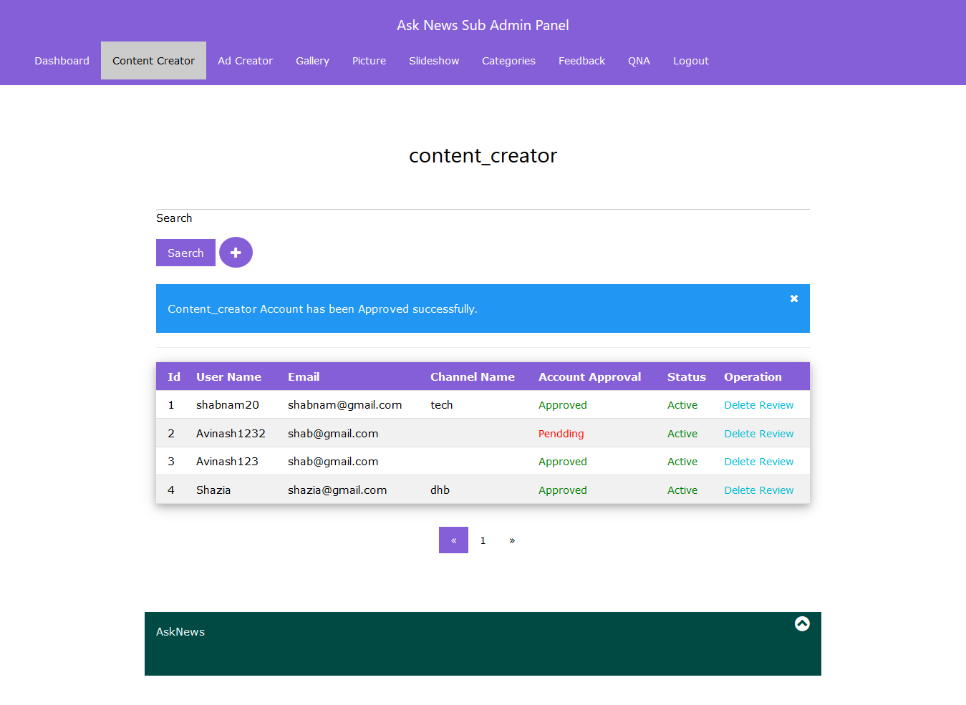
[4.2.16 Interface of super admin manage content creator]
Description: This is a page for manage user by super admin.

4.2.17 Sub admin login
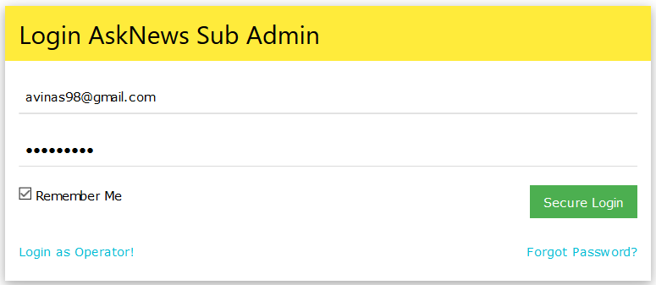
[4.2.17 Interface of sub admin login]
Description: This is a login page of sub admin. Enter email id and password and click on login button to login into dashboard.

4.2.18 Sub admin’s dashboard
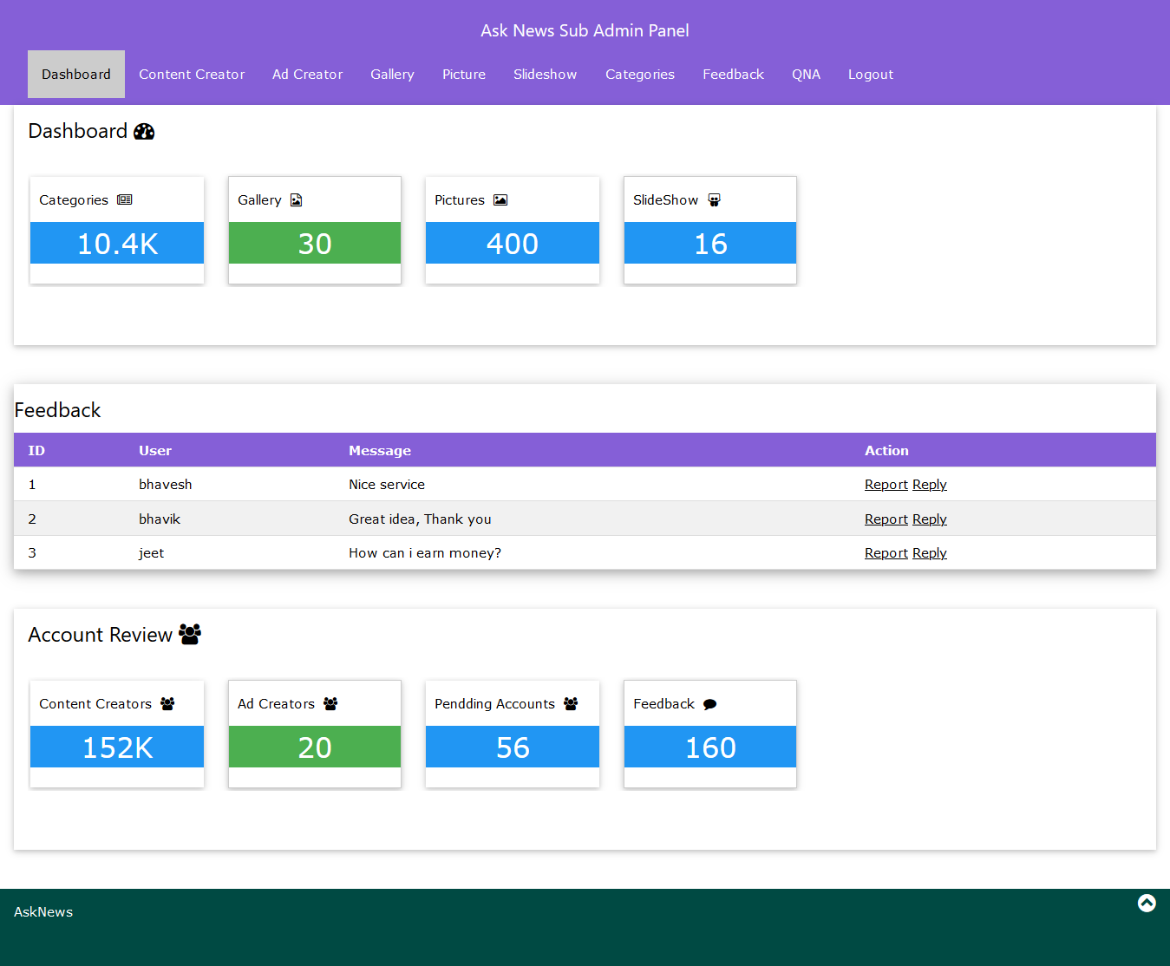
[4.2.18 Interface of super admin’s dashboard]
Description: This is use to display all details of content creator and ad creator.

4.2.19 Sub admin create new gallery
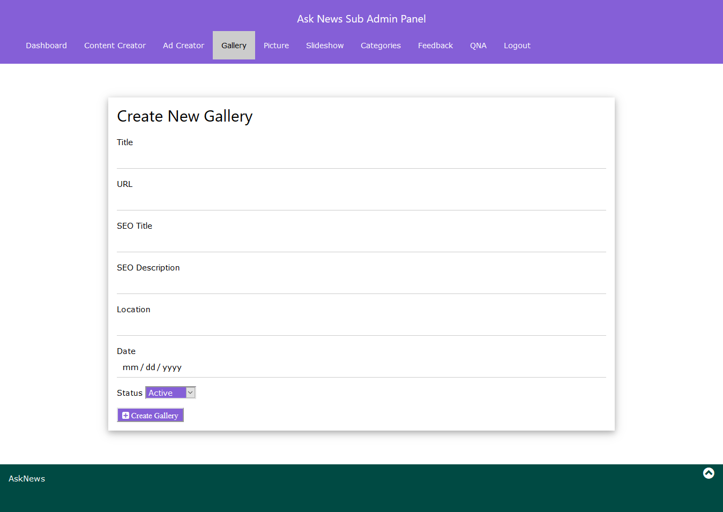
[4.2.19 Interface of sub admin create new gallery]
Description: This is a page for creating new gallery by sub admin. Enter all the details of gallery and click on create gallery.

4.2.20 Sub admin edit gallery
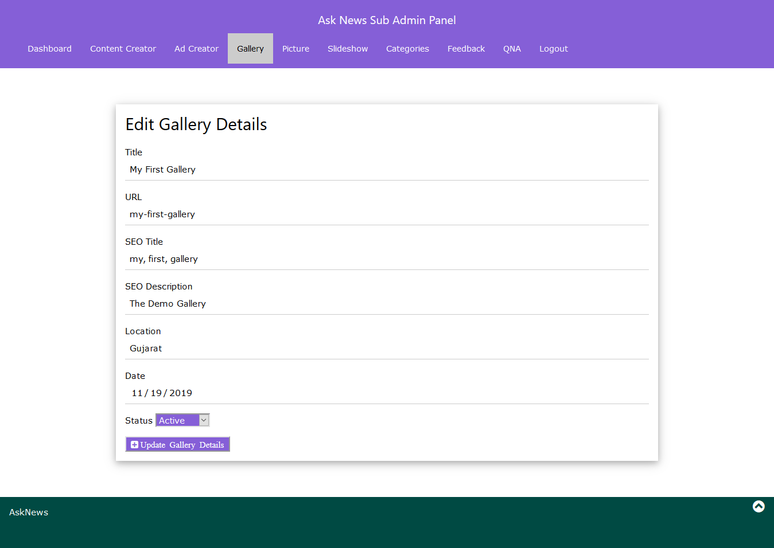
[4.2.20 Interface of sub admin edit gallery]
Description: This is a page for editing gallery by sub admin. Enter all the details of gallery and click on edit gallery.

4.2.21 Operator login
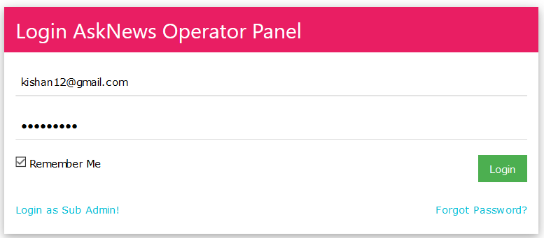
[4.2.21 Interface of operator login]
Description: This is a page login page of operator. Enter email id and password and click on login button to login into dashboard.

4.2.22 Operator’s dashboard

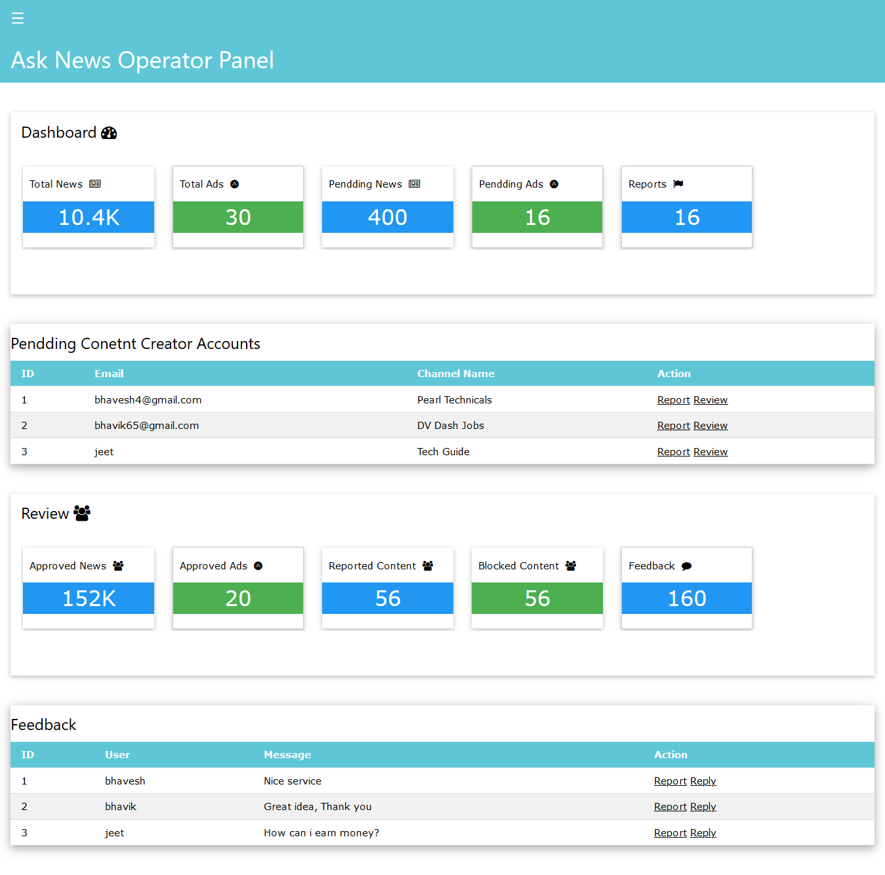
[4.2.22 Interface of operator’s dashboard]
Description: This is use to display all details of content creator.

4.3 Reports

4.3.1 Super Admin report for Sub-Admin and Operator

Input | User_status= Active_SubAdmin/InActive_SubAdmin/Active_Operator/InActive_Operator
Process | Select the user of specified type
Output | Username,  FirstName  LastName  Email  Role
Usage | To identify the numbers of Users is Active_SubAdmin/InActive_SubAdmin/Active_Operator/InActive_Operator.

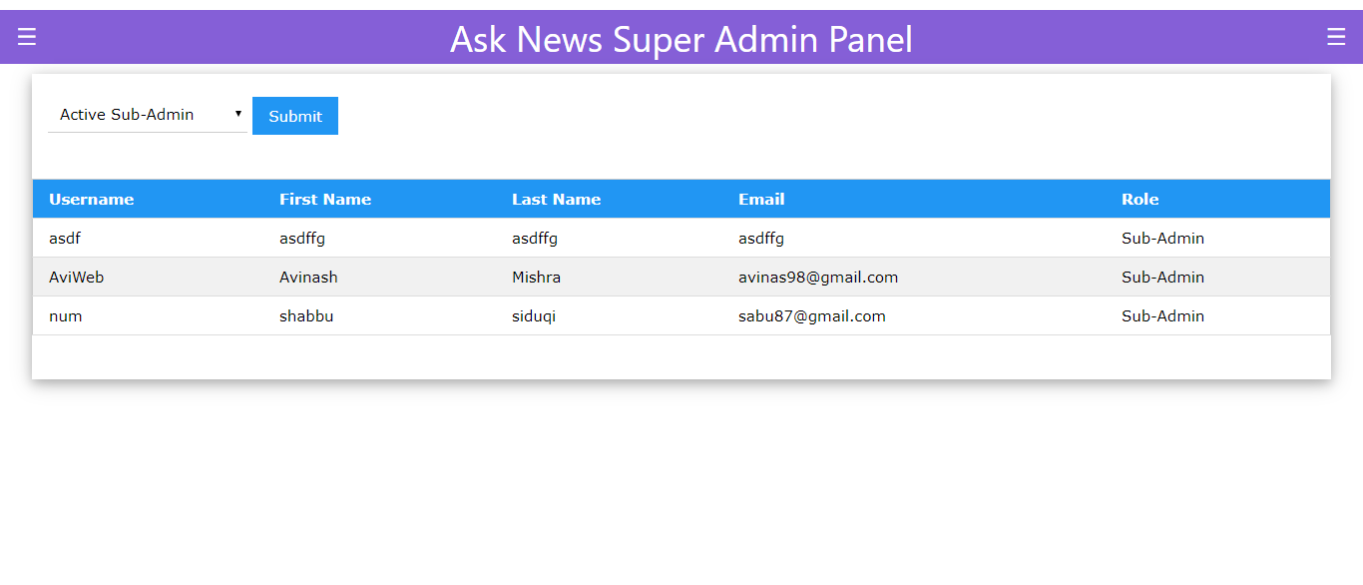
[4.3.1 Report of sub-admin and operator users how many of them are active or inactive]

4.3.2 Report of Sub-Admin

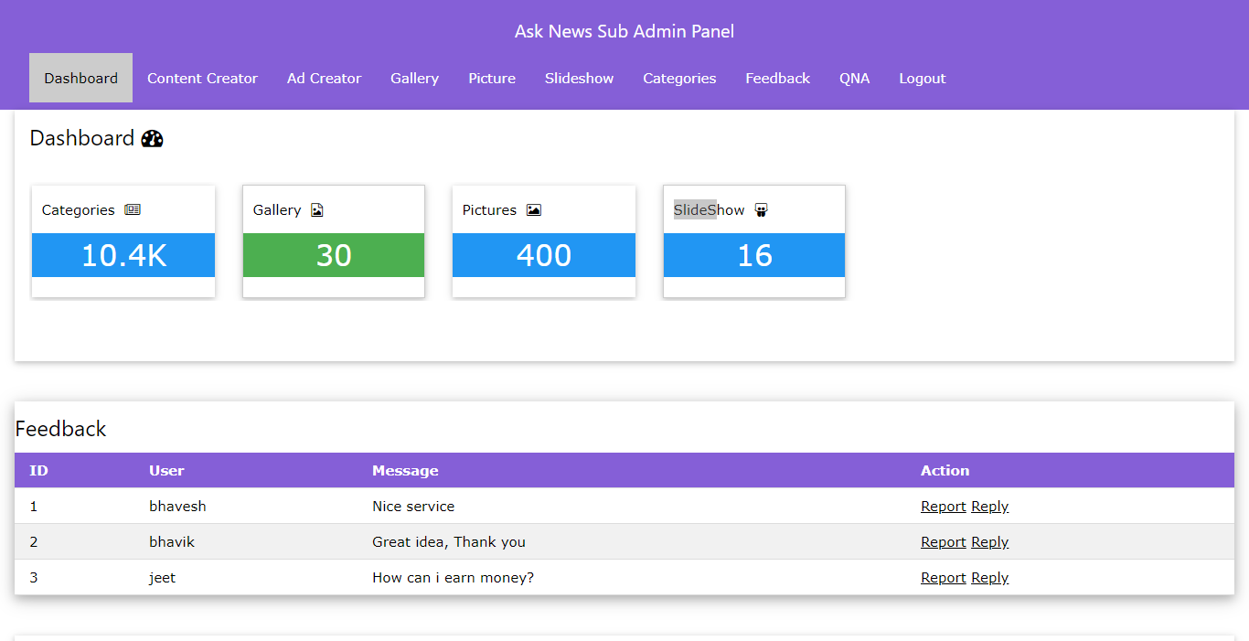
[4.3.2 Report of sub-admin for pending feedback]

4.3.3 Report of Operator
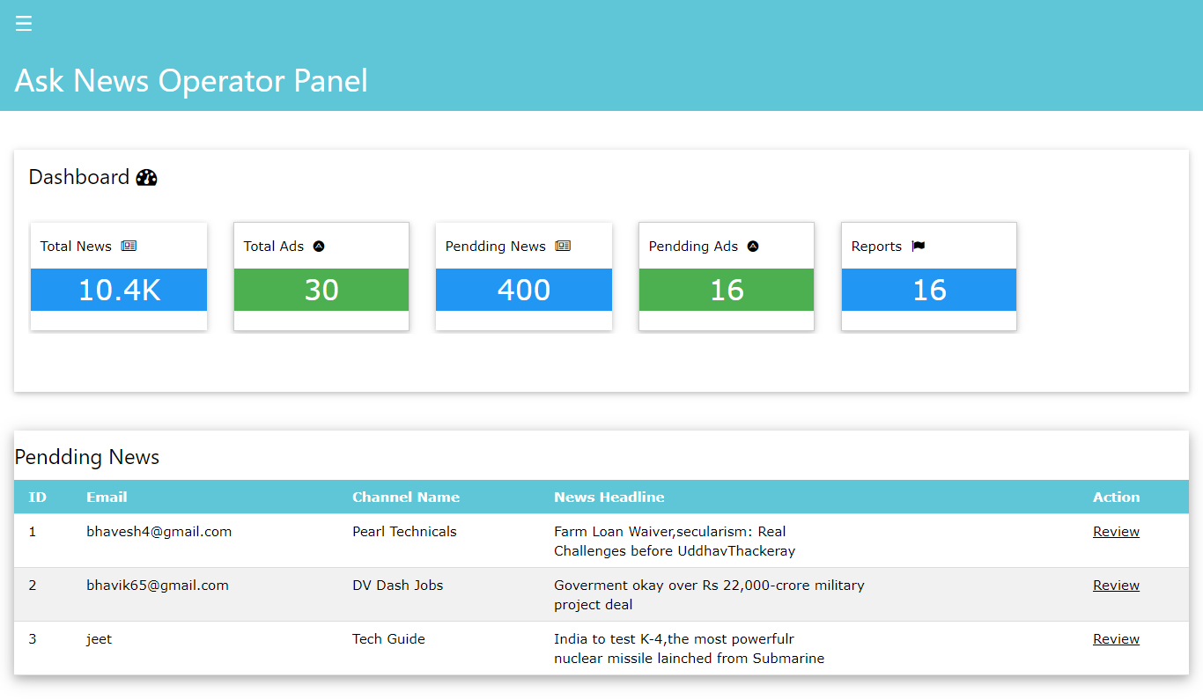
[4.3.3 Report of operator for pending news ]

4.3.4 Report of Content Creator
Input | News_status= Approved/pending/offline/Rejected/Draft
Process | Select the news of specified status
Output | News_title  News_image  Modified_date  Publish_date  Views  Status
Usage | To identify the numbers of news is approved/pending/offline/ rejected /draft.

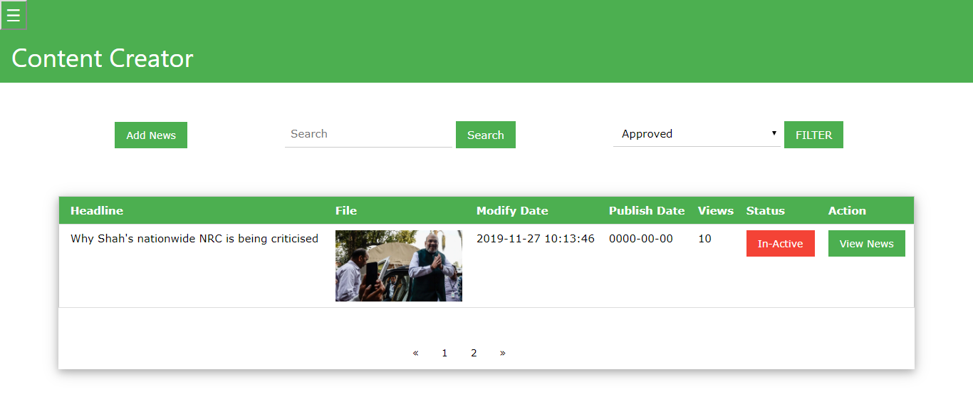
[4.3.4 Report of content creator for different types of news ]

5. References

5.1 Books
- Roger S. Pressman, “Software Engineering, A Practitioner’s Approach“ (seventh edition) [RP]
- Clarissa Peterson, “Learning Responsive Web Design”, A Beginner’s Guide, O’reilly publishing [CPL]

5.2 Web references
- https://w3school.com
- https://ckeditor.com
- https://ucnews.com
- https://Newsdog.com
- https://mp.ucweb.com/index.html

6. Timeline of Project
Srimad Rajchandra Institute of Management and Computer Application
MCA 3 Semester
Course Name: DSE4 Project Course Code: 040010321
Project Timeline Team No.: 1
Sr No. | Project Task | Duration | Estimated Start Date | Estimated End Date | Actual Start Date | Actual End Date | Status( complete/ pending) | Mode( Intime/Early/Delayed)
1 | Requirement Gathering
1.1 | Refer Related Website | 3 hr. | 26-08-2019 | 27-08-2019 | 01-09-2019 | 01-09-2019 | Complete | Delayed
1.2 | Defining the Purpose | 4 hr. | 28-08-2019 | 29-08-2019 | 02-09-2019 | 02-09-2019 | Complete | Delayed
1.3 | Defining Scope | 2 hr. | 30-08-2019 | 30-08-2019 | 03-09-2019 | 03-09-2019 | Complete | Delayed
2 | System Analysis
2.1 | Identification of Need | 1 hr. | 03-09-2019 | 03-09-2019 | 03-09-2019 | 03-09-2019 | Complete | In-time
2.2 | System Drawback & Advantage | 2 hr. | 04-09-2019 | 04-09-2019 | 04-09-2019 | 04-09-2019 | Complete | In-time
2.3 | Detemine Functional & Non-Functional Requirement | 3 hr. | 05-09-2019 | 06-09-2019 | 06-09-2019 | 07-09-2019 | Complete | Delayed
2.4 | Determine User & Userwise Requirement | 2 hr. | 09-09-2019 | 09-09-2019 | 10-09-2019 | 10-09-2019 | Complete | Delayed
2.5 | Determine Add-On Features or Distinct Functionality | 3 hr. | 10-09-2019 | 11-09-2019 | 12-09-2019 | 14-09-2019 | Complete | Delayed
3 | Defination Submission & Approval |  | 12-09-2019 | 13-09-2019 | 12-09-2019 | 19-09-2019 | Complete | Delayed
4 | Document-1 Report Preparation
4.1 | Proposed System
4.1.1 | Project Module | 6 hr. | 16-09-2019 | 19-09-2019 | 19-09-2019 | 21-09-2019 | Complete | Delayed
4.1.2 | Timeline Preparation-1 | 4 hr. | 20-09-2019 | 24-09-2019 | 21-09-2019 | 29-09-2019 | Complete | Delayed
4.2 | Conceptual Diagram
4.2.1 | UML Diagram / Use Case Diagram | 5hr. | 25-09-2019 | 27-09-2019 | 30-09-2019 | 11-10-2019 | Complete | Delayed
4.2.2 | Activity Diagram | 5 hr. | 30-09-2019 | 03-10-2019 | 01-10-2019 | 11-10-2019 | Complete | Delayed
5 | Document-1 Report Submission & Approval |  | 04-10-2019 | 03-10-2019 | 04-10-2019 | 07-10-2019 | Complete | Delayed
6 | System Design
6.1 | Database Design | 10 hr. | 07-10-2019 | 15-10-2019 | 18-10-2019 |  | Pending
7 | Presentation-1 Slide Preparation | 1 hr. | 15-10-2019 | 15-10-2019 | 13-10-2019 | 17-10-2019 | Complete | Delayed
8 | System Design |  |  |  |  |  | Pending
8.1 | Template Integration | 10 hr. | 17-10-2019 | 24-10-2019 | 17-10-2019 |  | Pending
8.2 | UI Design | 10 hr. | 07-11-2019 | 15-11-2019 | 04-11-2019 |  | Pending
9 | Timeline Preparation-2 |  |  | 07-11-2019 | 08-11-2019 |  | Complete | Delayed
10 | Presentation-2 Slide Preparation | 3 hr. | 18-11-2019 | 19-11-2019 |  |  | Pending
11 | Reports |  |  |  |  |  | Pending
11.1 | List All Reports | 6 hr. | 22-11-2019 | 27-11-2019 |  |  | Pending
12 | Document-2 Report Preparation | 6 hr. | 30-11-2019 | 02-12-2019 |  |  | Pending
 | Total Days | 89 hr. | 60 Days

